**Lead Registration (ABC Learning Centre)**

- capture potential customers (leads)

- customers = students & parents

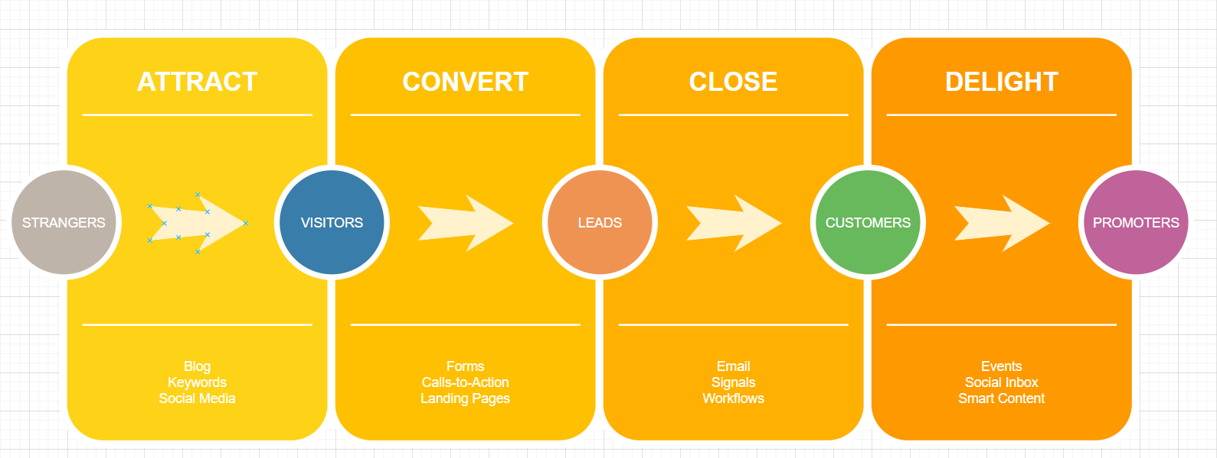

- name

- email address

- hp no

- course interested

- qualification

Administrators = staff in ABC = admin staff/course consultant

- contact customer

- provide more information

- convert from leads to confirmed customers

**Lead generation administration**

Maintain/manage the list of leads

- view the list

- add more data to the list

- extract the data into a excel/pdf format

- remove the data

- archive the data

- edit the data

ABC LC — why would it need an administration module?

Before having the website,

**Customer’s pov:**

- arrive at the office to record their interest

- office is closed - cannot inquire

- customers don’t know the operating hours

- phone calls to ABC LC

- engaged

- can’t get the correct number

- put on the hold —> frustration

- yellow pages

- can’t find in yellow pages

- look for people who is working and contact them directly

- not willing to engage with you

- the circle is v small and can’t find someone

**Course consultants’ pov:**

- answer difficult question on the spot

- bring physical form everywhere they go

- the copy is limited to course consultant

- communication history is not centralised

- time consuming: travelling to fill up/inquire/clarifications

- blank mandatory fields in the forms submitted

By having the website/lead registration form:

What benefit

- anyone can register their interest 24/7

- can do at the potential customer’s convenience

- basic information is readily available for them to gauge their interest in the products available

- mandatory fields —> form cannot be submitted if the fields are left blank —> reduce missing information

- save time —> more time to contact more leads —> more customers/students —> more revenue

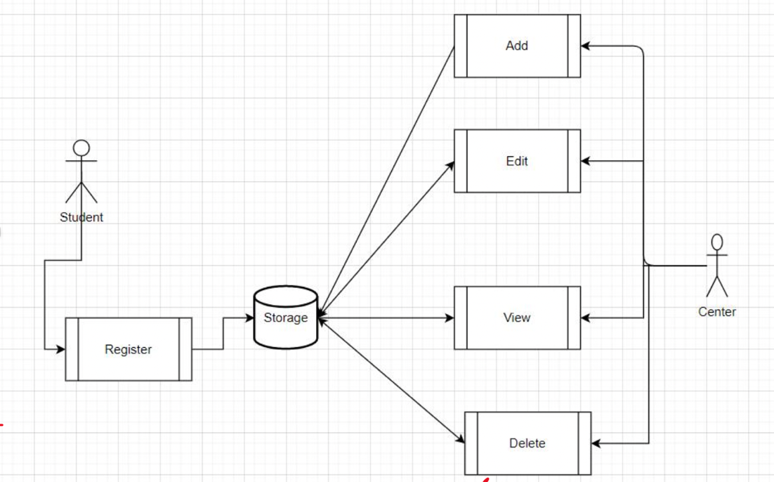

Testing

* Test the links
* Test the content
* Test CSS & JavaScript
* Test form (tests for 3 different fields)
  + Valid input
  + Invalid input

|  |  |  |  |  |
| --- | --- | --- | --- | --- |
| Test case | Test data | expected | actual | status |
| Valid name | Name: ayesha  Email: ….  …. | Form should be submitted  See thank you page | Form should be submitted  See thank you page | success |
| Empty name | Name:  Email: ….  …. | Get an alert to fill in name | Form should be submitted  See thank you page | fail |

* Test Local storage
  + Retrieval
  + Submitted data (registrationform.html)
  + Show a screenshot of local storage
  + Show the user.html
* Test with other browsers
  + Landing page
    - Chrome
    - Browser 2
    - Browser 3
* UX Metrics (for Usability Testing)
  + User satisfaction
    - Person 1 – give a rating out of 5
    - Person 2 – give a rating out of 5
  + Page clicks
  + Error rate
  + Conversion rate
  + Net promoter score
    - Person 1 – give a rating out of 10
    - Person 2 – give a rating out of 10
  + Time taken
    - Person 1 – 100s
    - Person 2 – 150s
    - Average time taken - 125s